**Experiment No 6**

Write a C program that takes, as a command line argument, the number of megabytes of memory it will use and during execution it should consume that much memory. Observe memory usage during program execution using free command.

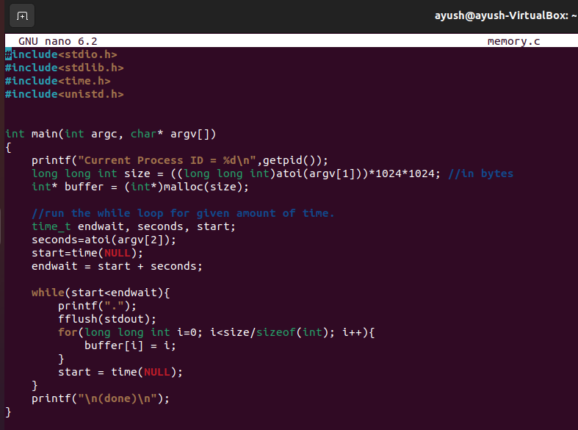

**>>Before executing the program**

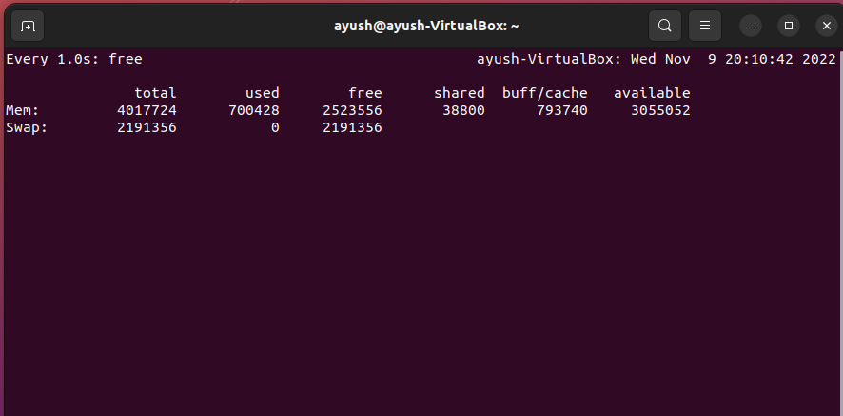

**>>After execution**

